**Lab Assignment # 2 Report**

**Mobile Client Application**

* I made a Mobile Application with Three general buttons - Welcome, Map Services and Video.

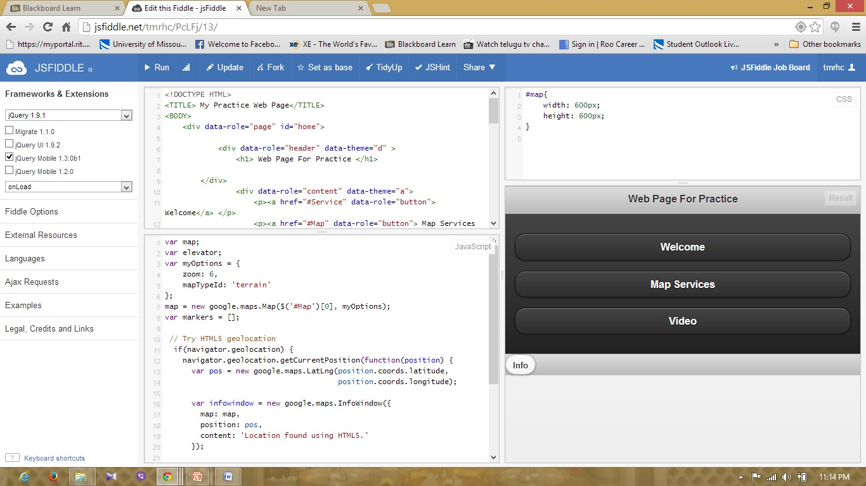

* The first Button is Welcome screen where the welcome image will be displayed when the button is pressed

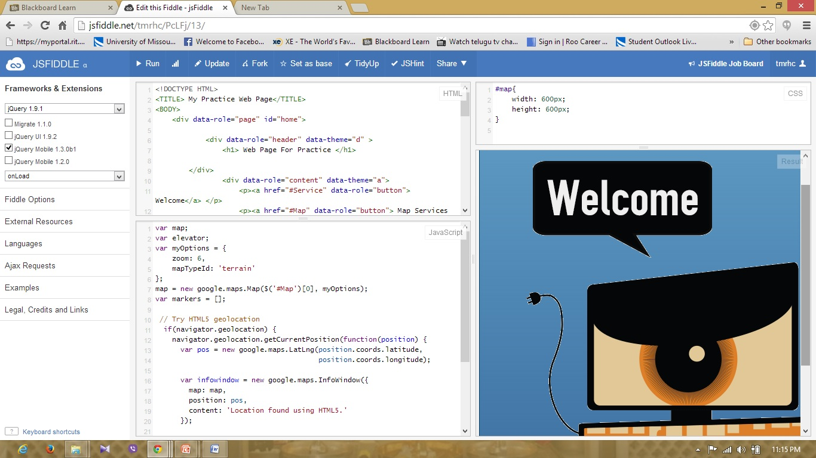

* The Second Screen is the geo location Map service where the current location will be displayed in google Maps

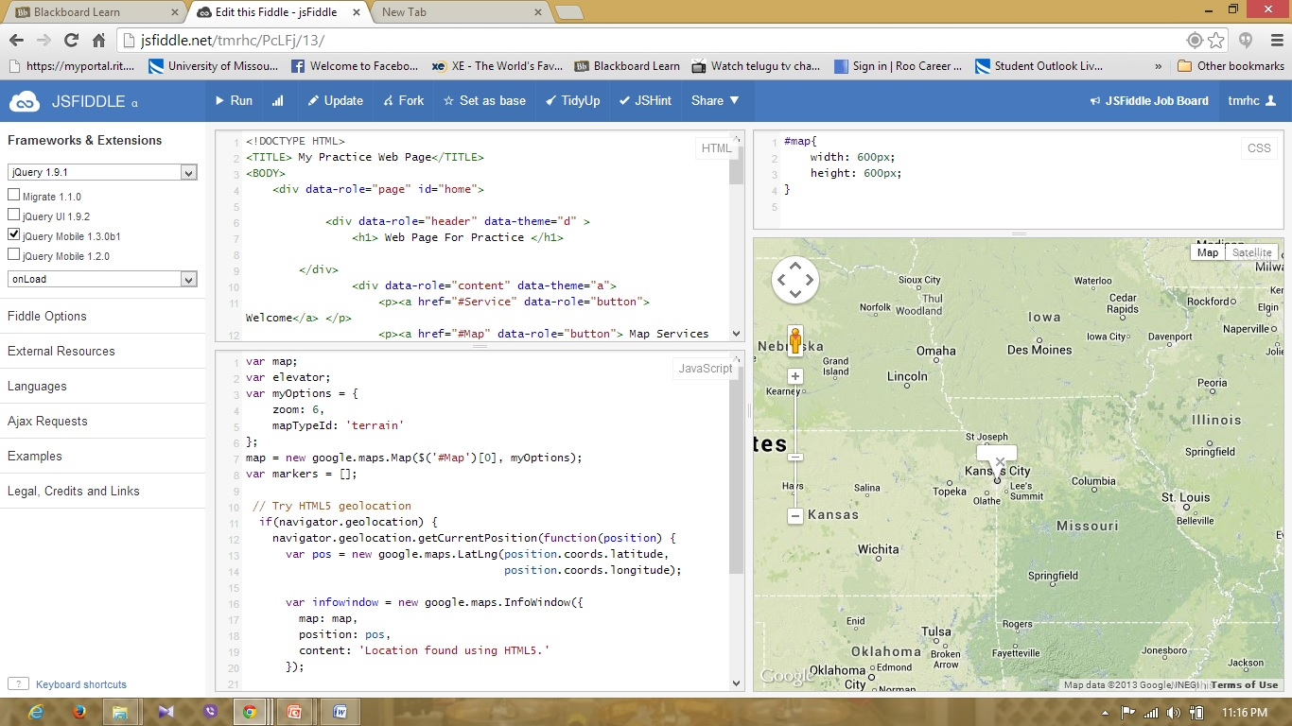

* The Third button is Video button where the Video will be displayed and can be played.

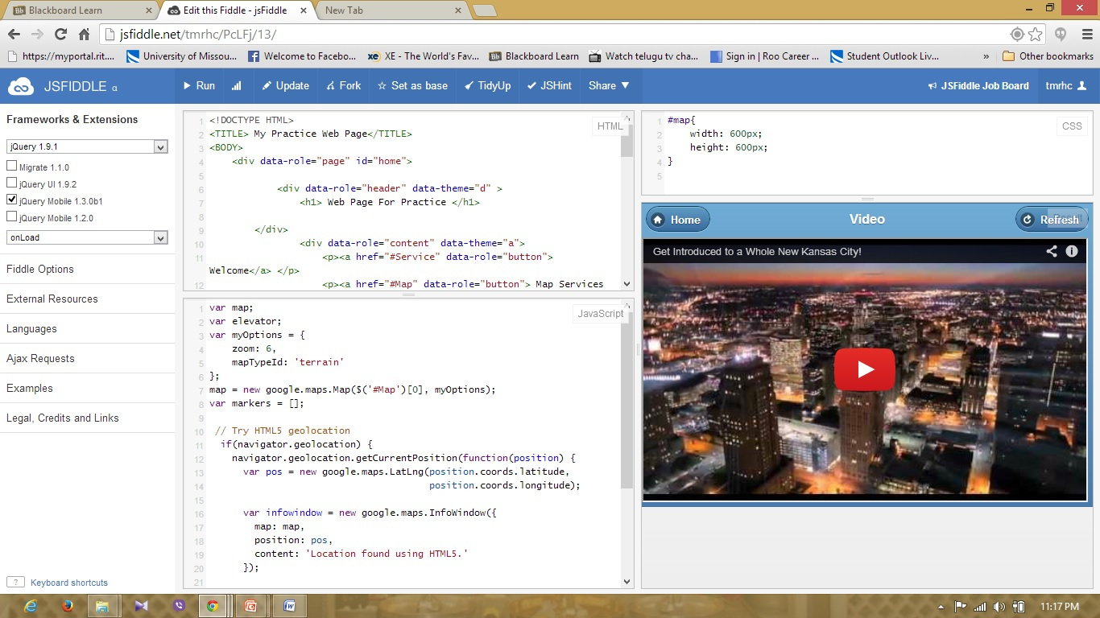

In addition to this I assigned Home button and Pop up is assigned in the home page when is pressed displays the Information.

